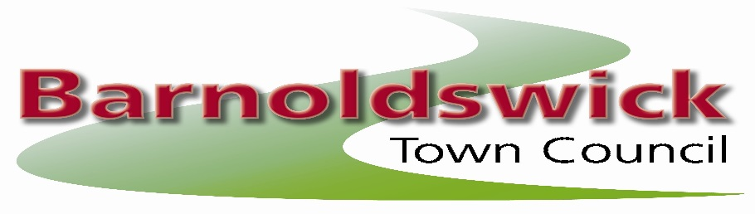

NOTICE OF VACANCIES ON TOWN COUNCIL

Barnoldswick Town Council is inviting applications from local electors to fill two vacancies as co-opted members of the Town Council.

Selection will be made by the Council following receipt of applications at the Council meeting on the 13th May 2026. No party affiliation is required and there will be no formal election.

If you're interested in becoming a co-opted member of Barnoldswick Town Council, please contact admin@barnoldswicktowncouncil.gov.uk for an application form. The application form will need to be submitted by 3rd May 2026.

This is an unpaid role. Upon receipt of your letter of application, you will receive further information about the appointment including a “Role Description”. Should you have any questions or require additional information then please contact the Council Chairman, John Spencer - johnspencer@barnoldswicktowncouncil.gov.uk.

