Barnoldswick Town Council
The Civic Hall, Station Road, Barnoldswick, BB18 5NA
Tel: 01282 788090
1st December 2020

TO: Members of the Full Council and press. You are summoned to attend a meeting of the Full Council to be held on Wednesday 9th December 2020 at 7pm, via Zoom, for the purpose of transacting the business on the agenda below.

This meeting is called under the Powers of Section 78 of the Coronavirus 2020 Act.
This meeting will be streamed on the Town Council’s YouTube Channel.

Members of the public are invited to send any questions to the Clerk by 12 noon on the day of the meeting. The live chat facility will be available on the YouTube Channel until the end of the Open Forum part of the meeting.

https://youtu.be/JGqz_VhdIWk

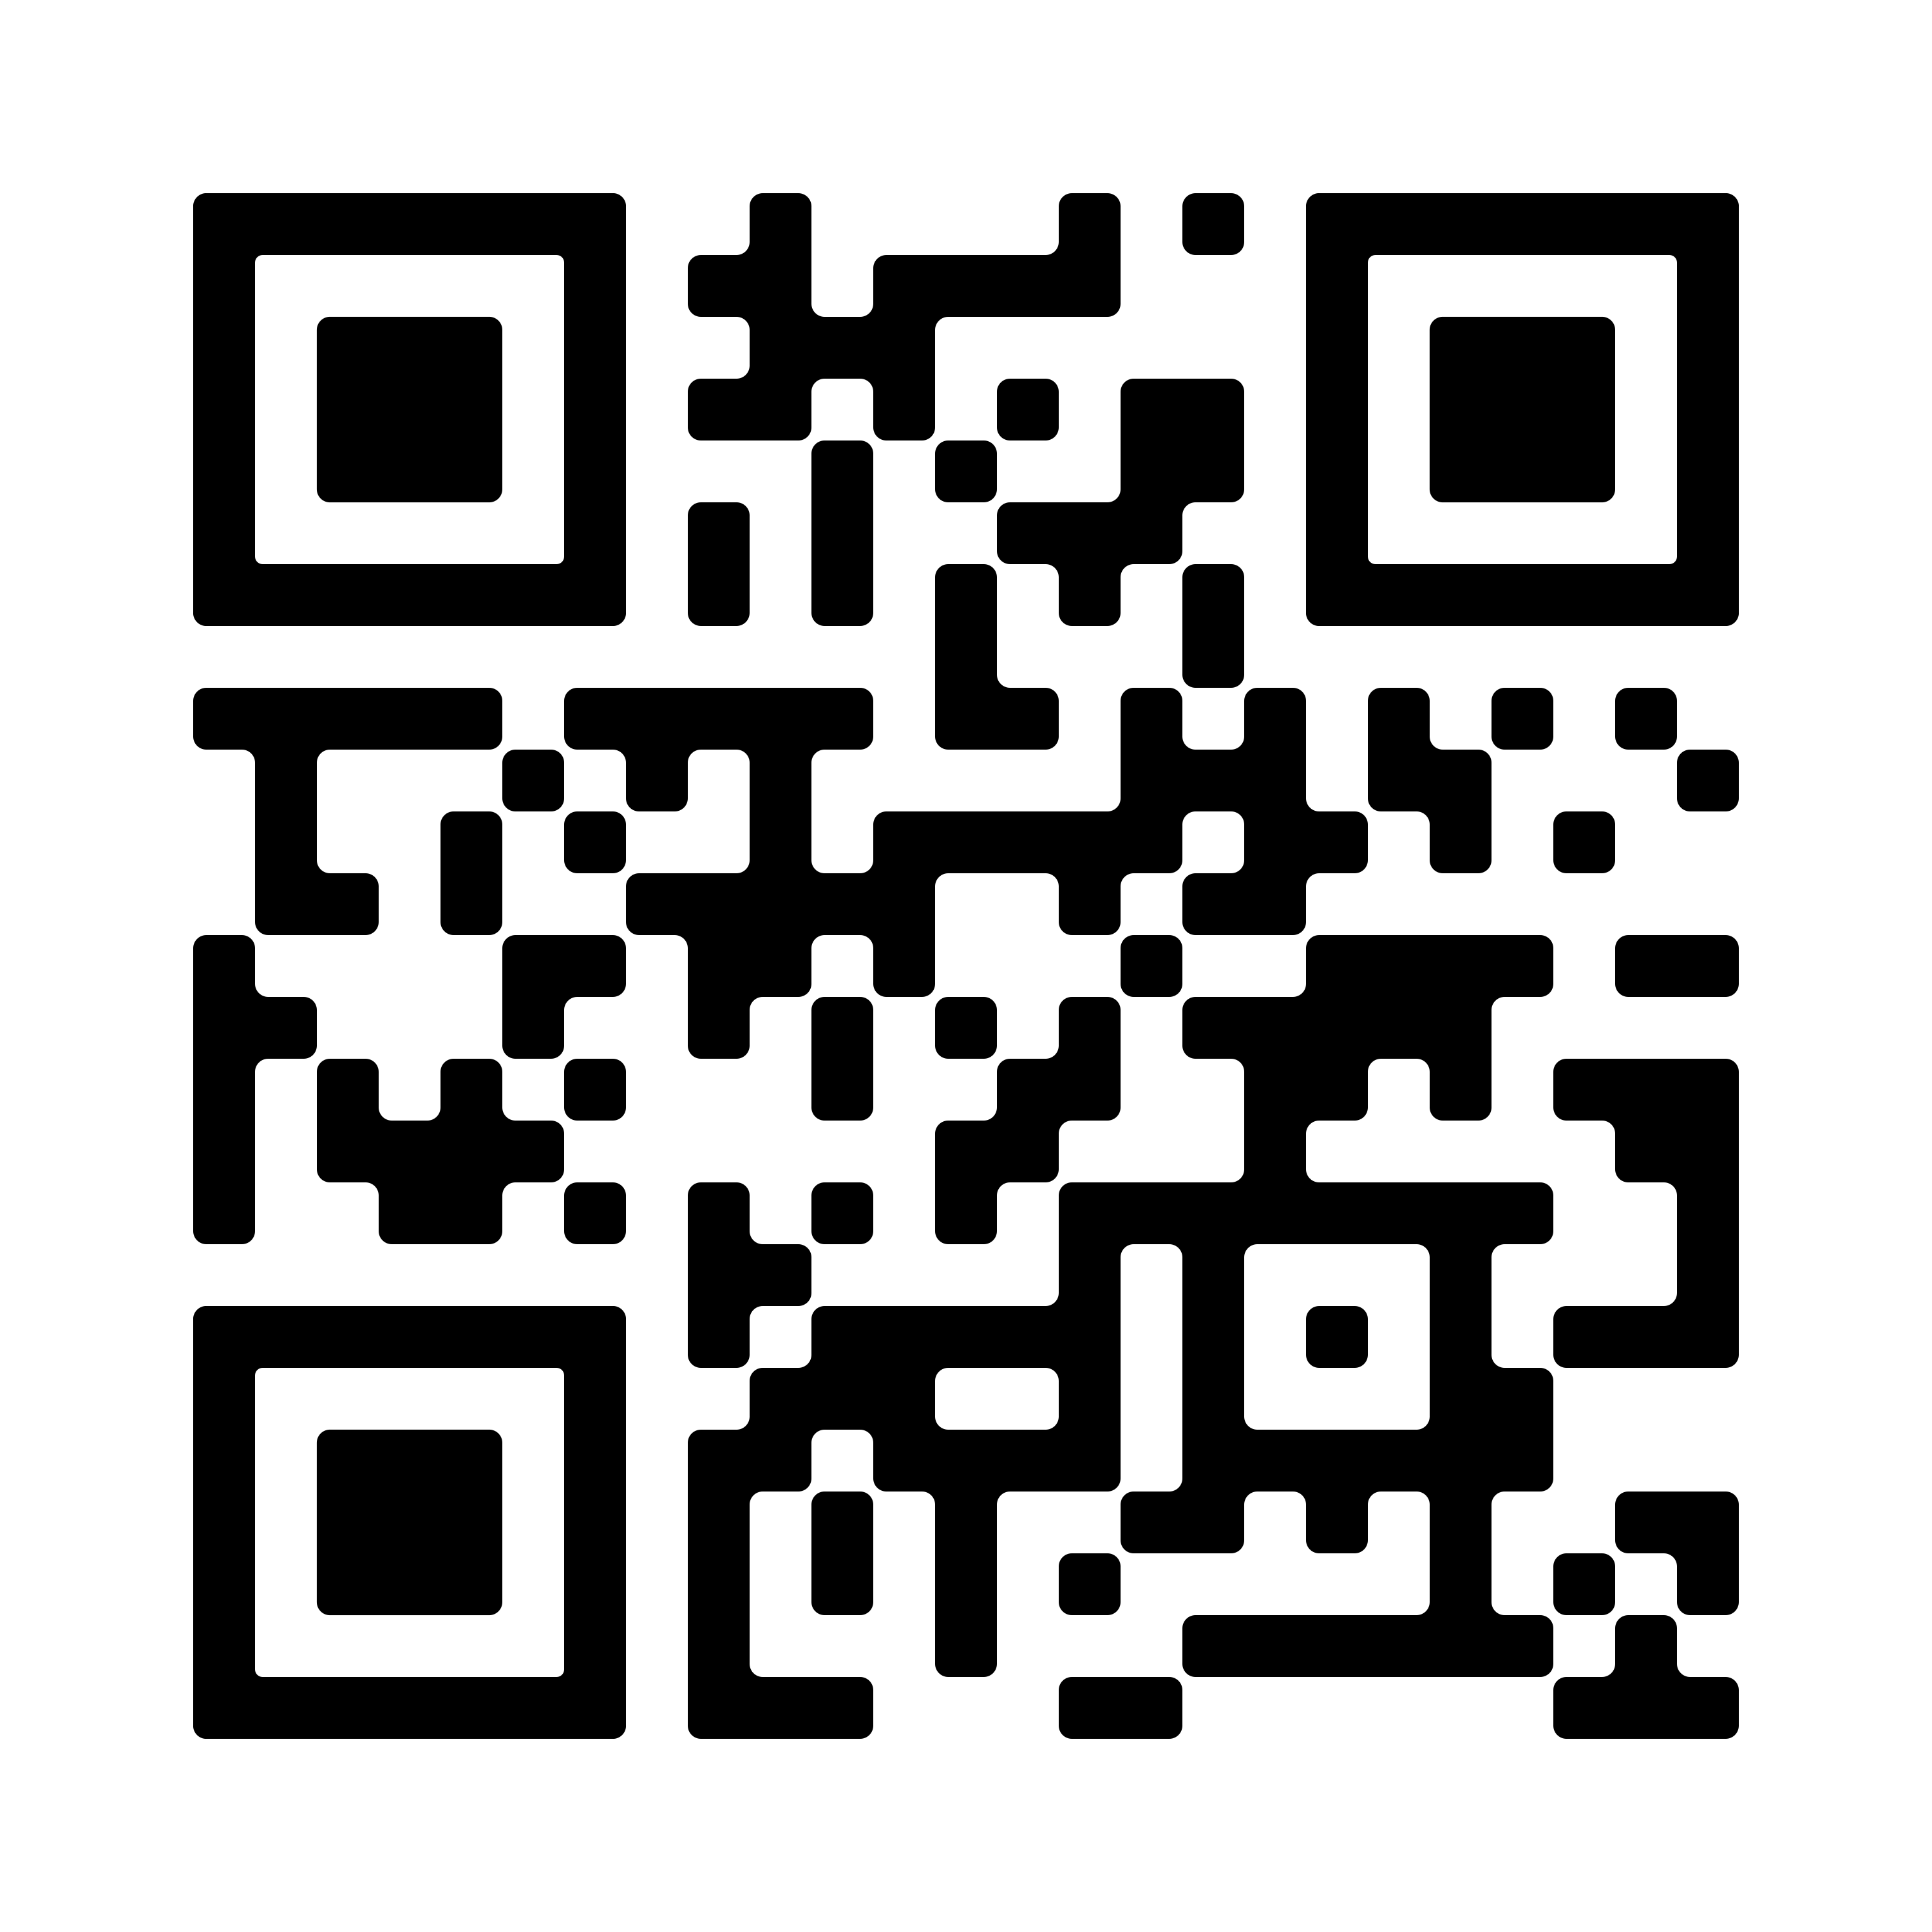

Joanne Geldard, Clerk to the Town Council

AGENDA
- Apologies for Absence
To report and record for absence from members of the council.

- Declaration of Interests
To disclose any pecuniary interests.

- Open Forum
To receive, for a maximum of 15 minutes, questions from members of the public on issues, which do not appear on the agenda.

- Minutes of the Last Meeting (Attached)
To approve and accept the minutes of the last meeting of the Council held on 7th October 2020.

- Committee / Working Groups reports (Attached).
To review and note the minutes of the committee / Working group meetings held since the last meeting of the Council.
  - General Purposes 18th November 2020

- Finance (Attached)
  - To confirm approval of payments made by the Town Clerk to the Council since the last meeting of the Council and to delegate consent for payments to be made prior to the next meeting of the council.
  - To advise the Town Council that the grant has been received back from The Rainhall Centre. £2500 was granted to The Rainhall Centre for a new projector and this project has been put on hold so the funds have been returned. To discuss re-allocating these funds to the Town Centre improvements.

- Completion of the External Audit
To report to Council the findings of the 2019/2020 external audit

- Dog Area – Victory Park & Letcliffe Park
To report on comments regarding the new area at Victory Park. To discuss making improvements to the area at Letcliffe Park

- Grant Application
To consider a request from Barnoldswick Town Junior Football Club for a grant of £2500 towards replacing the old posts and fences at the Junior Ground at Victory Park.
- To receive applications for co-opting two Town Councillors
For the Town Council to receive the applications for prospective Town Councillors and to select two applicants to fill the current positions.
- Co-option Voting Process The person co-opted must receive a majority of the votes of those Councillors present and voting at the meeting where the co-option takes place. Where there are two or more applicants for one vacancy, this rule means that a person must get a majority of votes over all the other applicants. Thus where applicant A receives four votes, and applicants B and C receive three votes and one vote respectively , A is not elected because he has the same number of votes as B and C put together and does not have a majority over their combined votes. Where there are more than two applicants it is desirable to eliminate the applicant with the least number of votes, so that the final vote is between two applicants only. After the vote the Clerk will notify the applicants of the results as soon as practicable.
- Successfully co-opted applicants become Councillors in their own right, with immediate effect having signed their Declaration of Acceptance of Office and are no different from any other member. Their term of office runs until the next quadrennial elections for the Town Council.

- Report from Buildings Working Group
To consider recommendations from the buildings working group for improvements to Town Council assets.

12) Correspondence/Items for Information (for information only)
To note an oral report from the Chairman/Clerk to the Council on items of information and correspondence received.

Contact: Joanne Geldard, Clerk to the Council,
The Civic Hall, Station Road, Barnoldswick, BB18 5NA
Phone: 01282 788090

The next scheduled meeting of the Full Council is on the 13th January 2020 – This is a change to the scheduled meeting time as the annual budget needs to be agreed and submitted – location determined on current Covid rules

