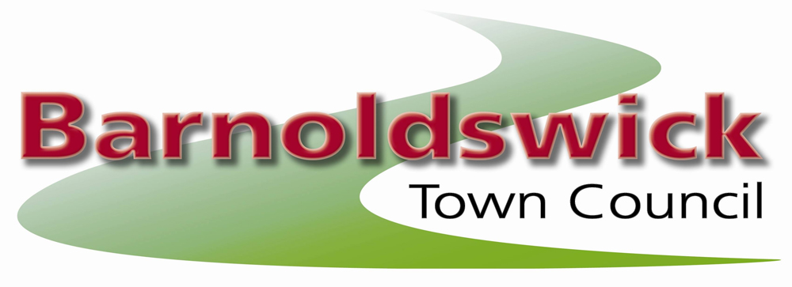
The Civic Hall, Station Road, Barnoldswick, BB18 5NA
Tel 01282 788090
3rd June 2026
TO: Members of the Full council and press.
You are summoned to attend a meeting of the Full Council to be held on Wednesday 10th June 2026 at 7pm, at The Civic Hall, for the purpose of transacting the business of the agenda below.
Members of the public are invited to send any questions to the Clerk by 12 noon on the day of the meeting. The meeting will be livestreamed on the Town Council YouTube channel.

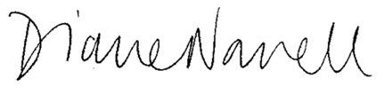
Diane Nowell – Town Clerk
AGENDA
- Apologies for Absence
To report and record apologies for absence from members of the Council.
- Declarations of Interest
In accordance with the requirements of the Councillor Code of Conduct, to disclose and declare any personal or prejudicial pecuniary interest(s) on any agenda item.
- Open Forum
For up to a total of 15 minutes representations from members of the public which are relevant to the Council. (standing order 27)
- Minutes of the last Meeting
To approve and accept the minutes of the Annual Meeting held 13th May 2026.
- Finance
  - To confirm approval of payments made by the Town Clerk since the last meeting of the Council and to delegate consent for payments to be made prior to the next meeting of the Council.
  - To approve updated Financial Regulations prepared in line with ‘Practitioners’ Guide 2025’ with amendments as discussed.
- Committees and Working Groups
  - To approved new Terms of Reference for the committees and complete document registers for each.
  - To establish Councillor membership for each committee.
- Planning matters
  - Planning applications
To consider planning applications:
26/0287/FUL, Higher Sandyford Farm Gisburn Old Road Barnoldswick
26/0293/FUL, 10 Rainhall Road Barnoldswick
  - Planning Appeals
26/0016/AP/COND, 2A Park Road Barnoldswick
- Web/IT review
To agree that the Clerk be tasked with reviewing the Council’s website and IT provision and to report back with recommendations for action.
- Transfer of Assets
Update following the Extraordinary Meeting on 3 June.
- Correspondence/Items for information only
To note an oral report from the Chairman/Clerk to the Council on items of information and correspondence received.
- Exclusion of Public and Press
Request to exclude the public per Schedule 12A of the Local Govt Act 1972, owing to the confidential nature of the business (Data Protection Act 1998).
- HR discussion
To vote on a confidential HR matter

The next meeting of the Full Council will be on Wed 8 July, 2026
For further information please contact:
The Clerk Tel 01282 788090 email: clerk@barnoldswicktowncouncil.gov.uk

