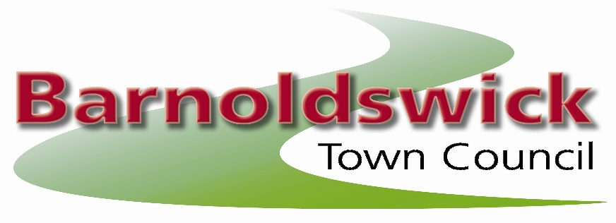
The Civic Hall, Station Road, Barnoldswick, BB18 5NA
Tel: 01282 788090
E-mail: barnoldswicktowncouncil@gmail.com

4th June 2025
Minutes of the meeting of the allotments committee held on Wednesday 4th June 2025 at the Civic Hall, Barnoldswick

Present: Cllr Jodie Greaves, Chris Church, Angela Moran & Callum Hird

Councillors:
Site Representatives: Phil Walker

25/01 Election of a Chairman
Nominations were asked for for the office of Chair for the year 2025-2026 It was proposed and seconded and resolved unanimously that Cllr Callum Hird be elected as Chairman.

25/02 Apologies for Absence
Received from Ian Holgate, Joyce Holgate, Alan French & Gillian Robinson

25/03. Open Forum
There were no questions from the public.

25/04. Declaration of Interests
There were no declarations of interest.

25/05 Minutes of the Last Meeting
The minutes of the meeting of the committee on the 2nd April 2025 were approved as a correct record

25/06 Reports from Site Representatives / Site Problems
Coates Hall
Resolved: all plots worked

Greenberfield

Resolved: Plot 15 send 30 days on 22nd May to re-inspect after 21st June

Hardy Avenue 2
Resolved: Plot 8a needs re-letting. Previous tenant failed to work the plot so notice given

Hardy Avenue 1
Resolved: plot 2c needs re-letting. Previous tenant failed to work the plot. Spoken to 4a re starting work and she assures us it will start this weekend. All other plots written to after the last inspection have made vast improvements so no further action.

Dam Head
No issues known

Havre Park
No issues known.

Coates Canal
No issues known.

Lower Park
Resolved: Plot 9 given 14 additional days to start work on the plot. Email sent asking what their intentions are as no work after 7 days (inspected 3/6)

West Close
Resolved: No issues known. Plot written to after last inspection has made improvements so no further action taken (inspected 3/6)

25/07 Allotment Vacancies / Waiting List / Update on rent collection
There are currently 159 people on the waiting list.
2 outstanding rents
2 vacant plots
Resolved: To note this information

Meeting dates changed to accommodate the committee:
6th August moved to the 30th July (this will be an inspection only and to meet at the Civic Hall at 6pm.
1st October to 8th October
Cancel 4th February
2nd April to 22nd April

Clerk to chase Tom re Greenberfield allotment project

The next meeting of the Allotment Committee will be on the 30th July 2025
Contact: Joanne Geldard, Town Clerk, Barnoldswick Town Council, The Civic Hall,
Station Road, Barnoldswick, BB18 5NA
Phone:01282 788090 e-mail:barnoldswicktowncouncil@gmail.com

Approved as a correct record of the above meeting

Signed……………………………………………….

Date………………………………………………….

Cllr Callum Hird – Chair to the Allotment Committee

