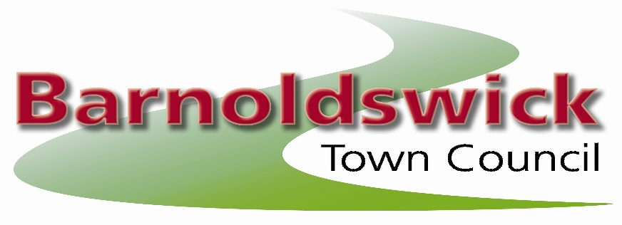
The Civic Hall, Station Road, Barnoldswick, BB18 5NA
Tel: 01282 788090
E-mail: barnoldswicktowncouncil@gmail.com

17th August 2022
Minutes of the meeting of the allotments committee held on Wednesday 17th August 2022 at the Civic Hall, Barnoldswick

Present:

Councillors: Chris Church & Callum Hird
Site Representatives: Gus Brennan, Gillian Allan, Ian & Joyce Holgate

22/01 Election of Chairman
The Clerk asked for nominations for the office of Chairman for the year 2022-2023. It was proposed by Gus Brennan and seconded by Chris Church and resolved unanimously that Cllr Callum Hird be elected as Chairman.

Cllr Callum Hird, Chairman in the Chair

22/02. Apologies for Absence
Received from Alan French & Jodie Hoyle

22/03. Open Forum
There were no questions from the public.

22/04. Declaration of Interests
There were no declarations of interest.

22/05 Minutes of the Last Meeting
The minutes of the meeting of the committee on the 16th March 2022 were approved as a correct record

22/06 Reports from Site Representatives / Site Problems

Dam Head
Letters have been sent to plot 4, 9, 10 & 15 previously. Plot 15 has undertaken work and is now satisfactory. Plot 9 has been served notice to quit. Plot 9 needs 30 days.
Complaint from a resident about ivy overgrowing the wall and trees spoiling their view.
Resolved: 30 day letters to 4 & 6a. Clerk to ring Pendle re wall & trees. The work has been done on the ivy from both sides of the wall – to advise homeowner that it will be up to the individual allotment tenants if they wish to cut back their trees.

Coates Hall

30 day letter to plot 7 & 11. New lock needed for site.
Resolved: To note that a re-inspection needed

Greenberfield

Plot 15 has had a 30 day letter. Repairs are needed to the fence
Resolved: To note that a re-inspection needed. Clerk to obtain quotes for work. To write to plot 5 to ask to cover up their beds. To write to plot 14 to ask them to collect their eggs more often and to get feeders off the floor as they are attracting rats.

Hardy Avenue 1

Plot 7 written to. NTQ to plot 5b (25/8/22)

Resolved: re-inspection needed & re-let 5b after 25/8/22

Hardy Avenue 2

The following plots needed work: 3a, 3b & 10d. To look at installing pedestrian gate at top end. New dog signs & lock on one side.
Resolved: 30 day letter to 3a, 3b & 10d. Look at gate, install dog signs and lock

Havre Park
No site rep but no issues known.

Coates Canal

No issues.

Lower Park

Plot 4 & 8 given NTQ (25/8/22)
Resolved: re-let after 25/8/22

West Close

No issues
Resolved: To note this information.

22/07 Allotment Vacancies / Waiting List / Update on rent collection
There are currently 168 people on the waiting list.

There are currently no vacant plots.

3 allotment rents outstanding and Clerk given notice to quit to all.

Resolved: Note this information

22/08 Land at Greenberfield
Clerk has been unable to contact the person proposing to undertake the project.
Resolved: re-look at plans and take to Council

The next meeting of the Allotment Committee will be held on the 19th October 2022 at 7pm at The Civic Hall
Contact: Joanne Geldard, Town Clerk, Barnoldswick Town Council, The Civic Hall,
Station Road, Barnoldswick, BB18 5NA
Phone:01282 788090 e-mail:barnoldswicktowncouncil@gmail.com

Approved as a correct record of the above meeting

Signed……………………………………………….

Date………………………………………………….

Cllr Callum Hird – Chair to the Allotment Committee

