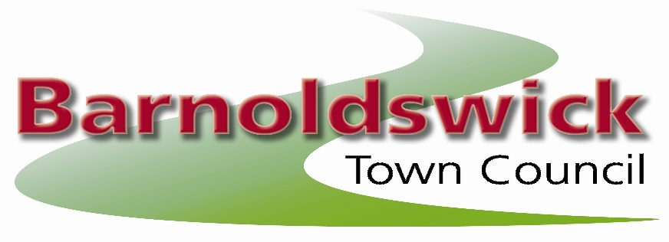
The Civic Hall, Station Road, Barnoldswick, BB18 5NA
Tel: 01282 788090
E-mail: barnoldswicktowncouncil@gmail.com

16th March 2022
Minutes of the meeting of the allotments committee held on Wednesday 16th March 2022 at the Civic Hall, Barnoldswick

Present:

Councillors: Cllr Chris Church, Cllr Tom Whipp, Cllr Jodie Hoyle & Cllr Callum Hird
Site Representatives: Ian Holgate, Joyce Holgate, Alan French, Gillian Allan & Gus Brennan

21/15 Apologies for Absence
Received from

21/16 Open Forum
There were no questions from the public.

21/17 Declaration of Interests
There were no declarations of interest.

21/18 Minutes of the Last Meeting
The minutes of the meeting of the committee on the 13th October 2021 were approved as a correct record

21/19 Reports from Site Representatives / Site Problems

Dam Head
Trees have been cut down as requested.
Resolved: To give Graham Taylor his rent for free in return for the tree work. Chase up wall

Coates Hall
Resolved: To look in to ownership of fence, plot 4 notice to quit as no work done for a year.

Greenberfield
Resolved: to carry out works to boundary fence

Hardy Avenue 1
Resolved: arrange for hedge to be cut back. 30 days to 2 plots

Hardy Avenue 2
Resolved: nothing to report

Havre Park
Resolved: to contact Gareth Aspey about the waste put on the allotment plot after the culvert was cleared

Coates Canal
Resolved nothing to report

Lower Park
vote taken on whether a plot could be transferred in to a plot holders brothers name after he passed away
Resolved: To decline this request as it would set a precedent and due to the size of the waiting list.

West Close
Resolved: To ask Gareth Aspey to look at flooding on the site.

21/20 Allotment Vacancies / Waiting List / Update on rent collection
No vacancies, 171 on list and 100% collection last year.
Resolved: To note this information

21/21 Allotment Rents
Resolved: To note this information

The next meeting of the Allotment Committee will be set at the full council meeting on the 11th May 2022
Contact: Joanne Geldard, Town Clerk, Barnoldswick Town Council, The Civic Hall,
Station Road, Barnoldswick, BB18 5NA
Phone:01282 788090 e-mail:barnoldswicktowncouncil@gmail.com

Approved as a correct record of the above meeting

Signed……………………………………………….

Date………………………………………………….

Cllr Tom Whipp – Chair to the Allotment Committee

